**QR- based Advance Attendance System Using 2-Step Authentication**

Prof. V.K Sambhar

[vksambhar.sae@sinhgad.edu](mailto:vksambhar.sae@sinhgad,edu)

contact:-+918805192409

Aditya Ekunkar

Ankit Kakade

Atharva Inkar

Harsh Hiradeve

SINHGAD ACADEMY OF ENGINEERING, PUNE

Department of Computer Engineering

**Abstract**— Student participation in the classroom has a direct impact on their academic success in higher education institutions. The majority of student attendance registration is still done in the traditional manner, which is cumbersome and time- consuming, especially for courses with a significant number of students.The majority of institutions have historically handled attendance control by hand. The goal of this paper is to encourage the potential use of the Quick Response (QR) code as a future attendance management system, to track and record student attendance in lectures and exercises for all pertinent courses, in order to resolve the manual attendance issues. We proposed and implemented a smart attendance system to do this.

**Keywords**:-QR Code, attendance, system, professor, student.

**INTRODUCTION**

Nowadays, it’s crucial to complete tasks quickly, pick up new skills, and get better results as quickly and effectively as you can. Every sector needs management systems to enable them to have proper control and management in the development of learning or work, notably the educational process and the corporate world. We concluded that an online system to track student attendance is necessary for the university education process in particular after taking all these advantages and benefits into account. Regular attendance is among the most fundamental and crucial requirements in the educational system.

As a result, if the attendance requirement is not reached, the student may forfeit their ability to take an exam. Additionally, if students take more absences than permitted, they risk losing their ability to take the final exams. Given this, there is room for more calculation errors in the existing manual method. In order to address these problems, we suggested and created a superior web-based approach. Users of different computer systems, tablets, and mobile devices can utilise it with ease. The suggested approach offers data protection, allows for quick and easy access to attendance data for the entire class or specific students, and automatically generates reports for the professor. Using a special code for each professor and student known as a QR code, the internet-based attendance system’s goal is to computerise the conventional method of recording attendance and to give a simpler and more advanced approach to track institutions’ attendance today. Users (professors and students) are required to scan their individual QR code provided to them during or at the commencement of each lecture using QR reading devices within the classrooms at the start of each course to verify their attendance. The lecture and student attendance records as well as other essential information will be recorded in light of this. The approach will save a tonne of time while greatly enhancing student attendance in specific courses they must attend.

**Project Objective:**

* To represents an analysis of different technologies which are used for taking attendance system.
* To design and develop automated attendance systems.
* This system can be implemented for better results regarding the management attendance.
* This system will save time, decrease the amount of work the administration has to do.
* This system that is adaptable, affordable, simple to use, and capable of integrating with an educational institution's future development.

**Motivation**

* Most student attendance is still registered using the outdated method, which is difficult and time-consuming, especially for courses with a significant number of students.

**Problem Statement**

* Attendance Management System is software developed for daily student attendance in colleges and institutes. It facialtes to access the attendance information of a particular student in a particular class. This system will also help in evaluating attendance eligibility criteria of a student. By just a click on the mouse the system will be able to produce the students attendance report thus reducing the need for manual labour which is prone to human errors and time consuming.

**REVIEW OF LITERATURE**

Muhammad Ayat Hidayat, Holong, MarisiSimalango :- In this paper, We require a system for tracking student attendance that is effective at gathering information rapidly. By gathering data, analysing the system, designing the system, and putting it into practise, this student attendance system is accomplished. Android and PHP programming languages were used to construct this system. The goal of this project is to develop student-facing applications for attendance tracking and class notification systems based on IBEACON.

Dr.Nkolika O. Nwazor, Mumuni M. Olusolape:- This work uses the Centre for In- formation and Telecommunication Engineering at the University of Port Harcourt as a case study to design a cloud-based attendance management and information system. The implementation of a radio frequency identification tag reader and tag makes it possible to collect attendance data from both staff and students. A cloud-based information system application processed and stored the data received once it was processed from the tags’ data.

FawazAlassery:- In this study, we present a WSN-based time attendance system with sensor nodes embedded in sophisticated seats. We design a smart classroom that has five HX711 amplifiers and twenty 50 kg load sensors.

NandgopalDevnath, Nitin Pasi- This paper describes a created system that has been successfully constructed and tested. Analysis and export of the student’s attendance data will take place. Our daily lives depend greatly on the attendance tracking system. The most accurate code scanning technology available is the QR Code Based Smart Attendance System, which is a truly amazing advantage.

VasutanTunbunheng- In this paper, When collecting attendance, the DroidScript programme has to be connected to the internet because it uses Google’s speech recognition service for this study. In order to send data later when you connect to the internet, it may be better to register data when you’re not connected. This project could be expanded to include the collection of student grades for tests ad- ministered on paper. Another approach to expand this work is to have the students read their own codes and record their own noises to verify their identities.

Dongmei Feng, Peng Wang, Lei Zu:-This system satisfies the requirements of college professors and creates a fingerprint instrument, upper computer, and lower computer-based class attendance system. Once their fingerprints have been registered, students can carry out permanent fingerprint attendance.

Jaehoon (Paul) Jeong, Minho Kim, Yeonghyeon Lee, and Patrick Lingga:-This article suggests an Internet of Things-based Automatic Attendance System (called IAAS). Our objective is to offer a face recognition technology that is more depend- able and better for automatic attendance verification. To do this, a better system structure is built utilising appropriate face recognition technologies, and user face data is extracted using training data and the Haar-cascade method using training data.

Jack FebrianRusdi, Frans Richard Kodong-This system is based onface recognition for recording for recording education system for institutes, either as the primary system or as a support system for an already existing system.

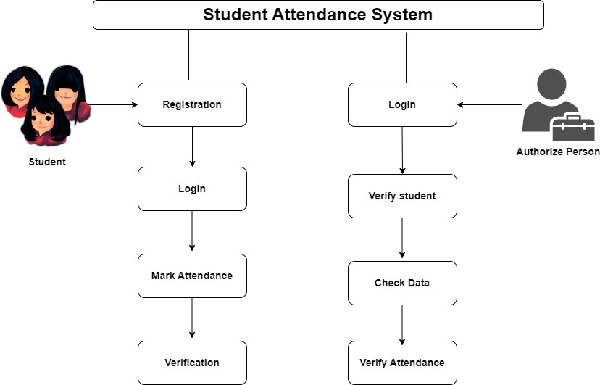**Proposed System**

**Figure 1. System Architecture**

**RESULTS AND DISSCUSSION**

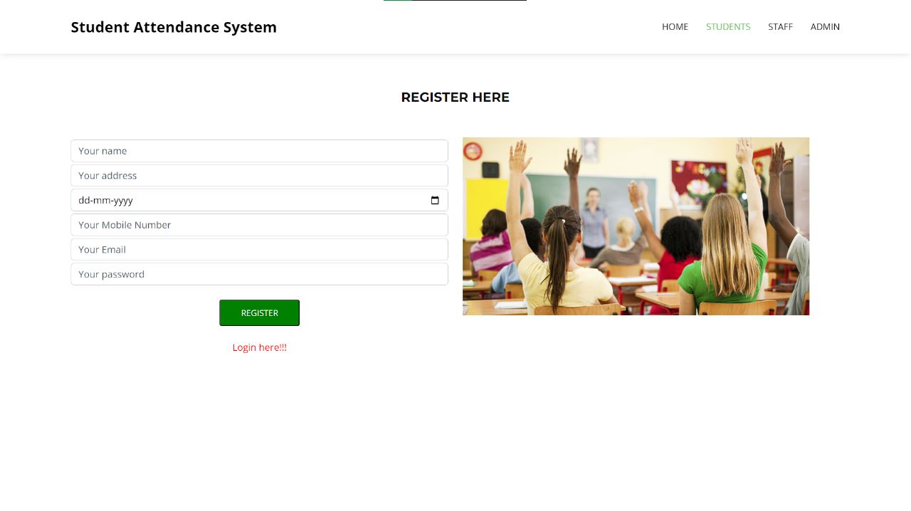

**Fig:-Student registration**

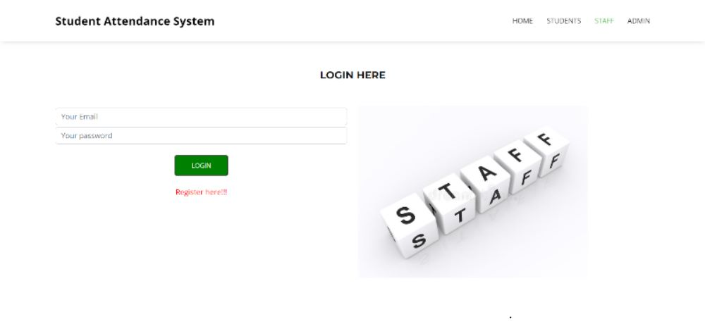

**Fig:-Staff login**

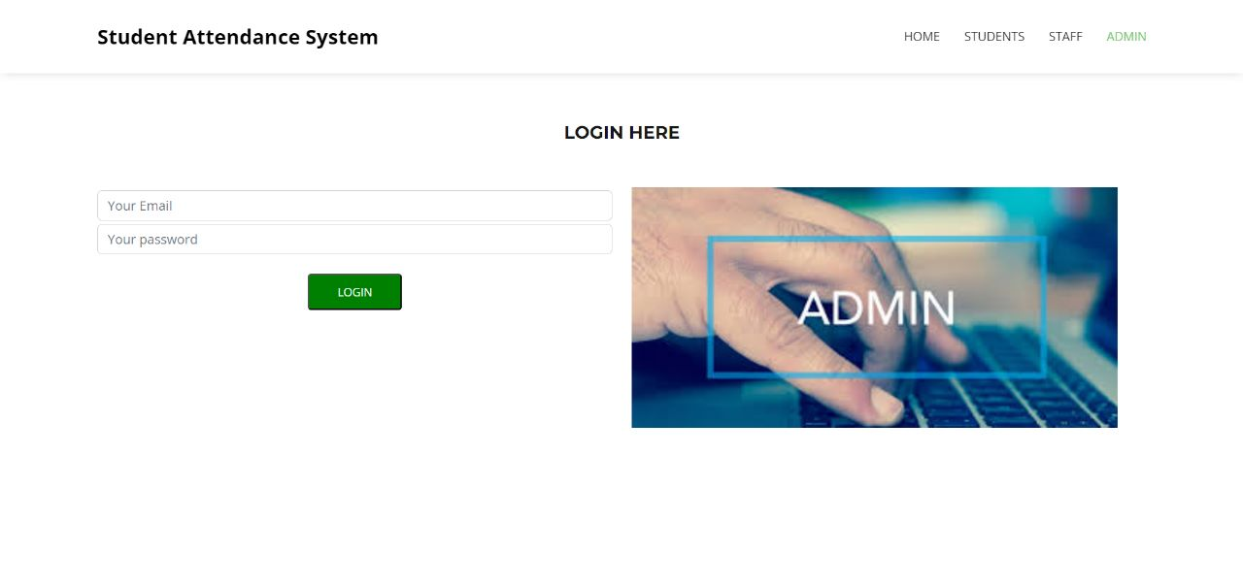

**Fig:-Admin Login**

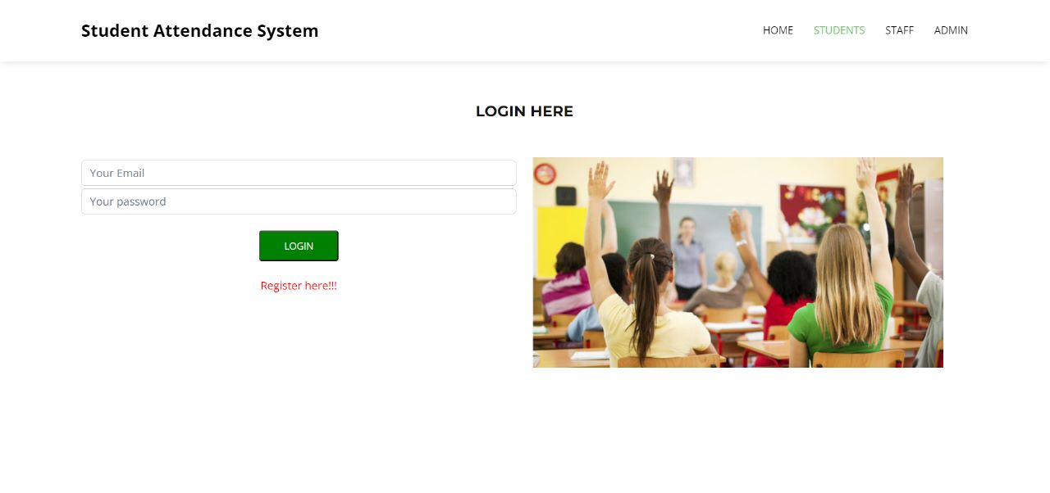

**Fig:-Student login**

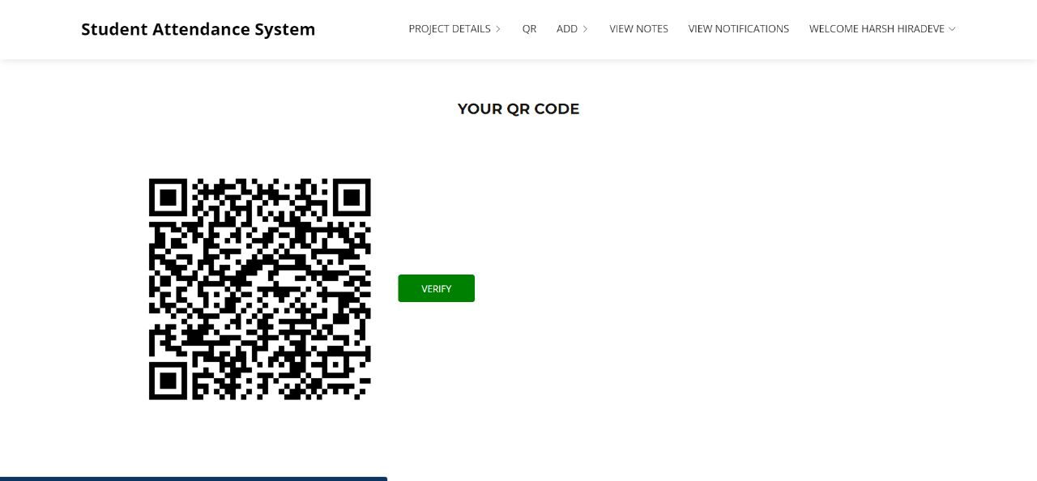**Fig:- Student QR**

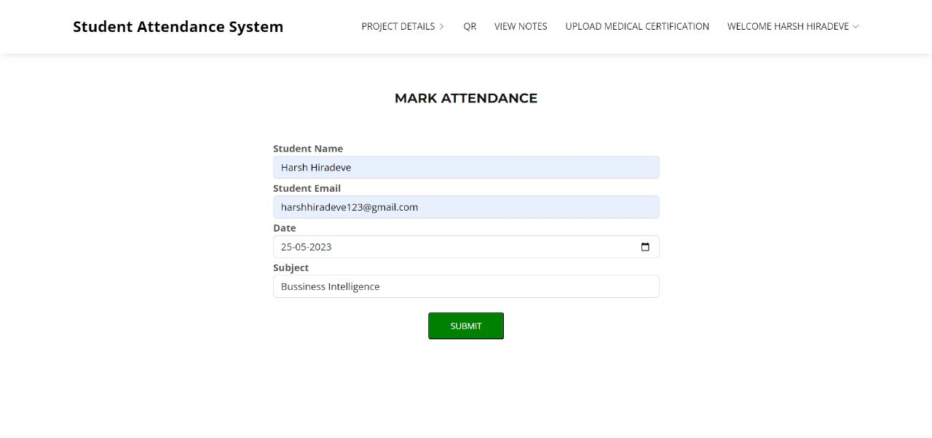

**Fig:-Mark Attendance**

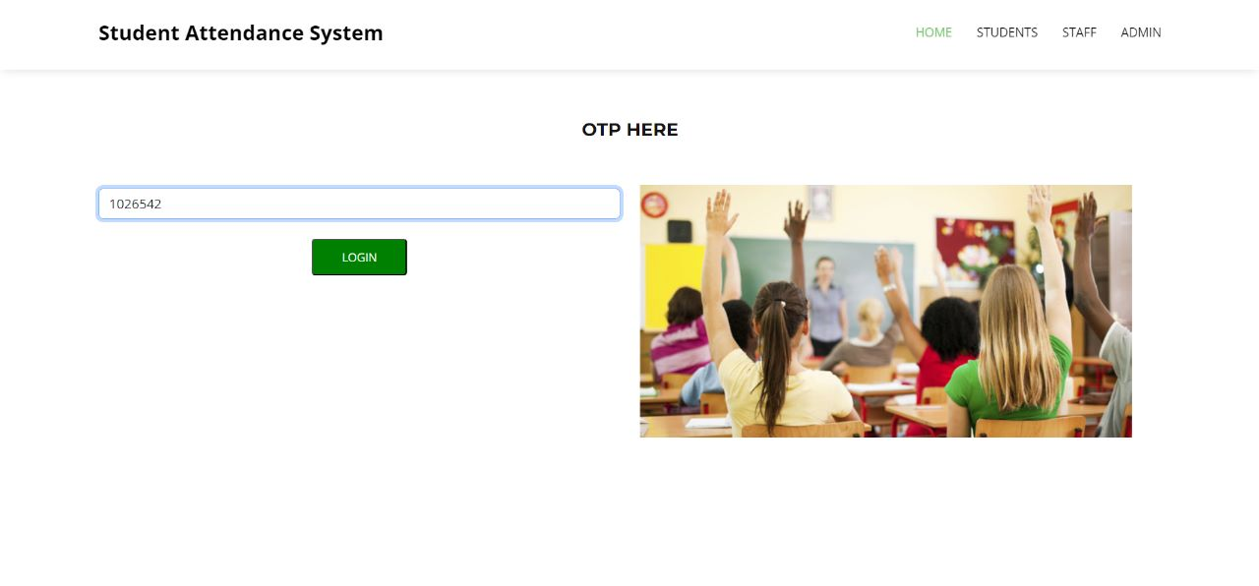

**Fig:-OTP**

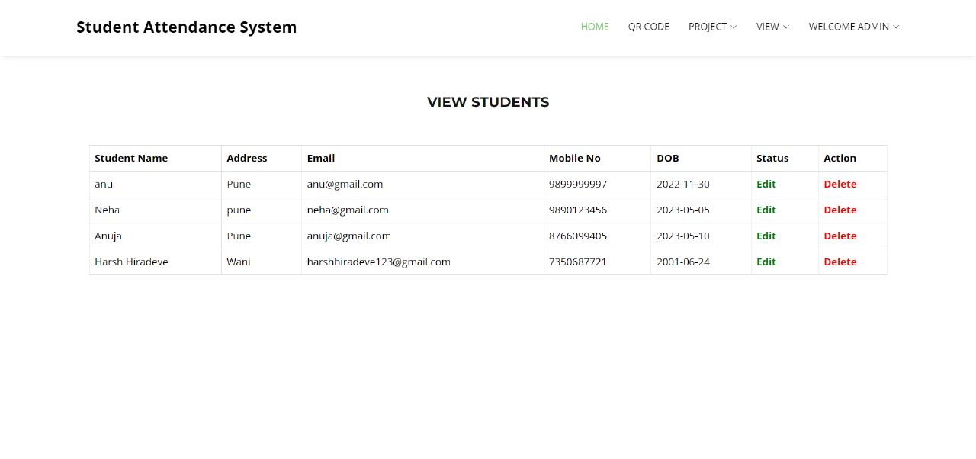

**Fig:-Admin home student details** 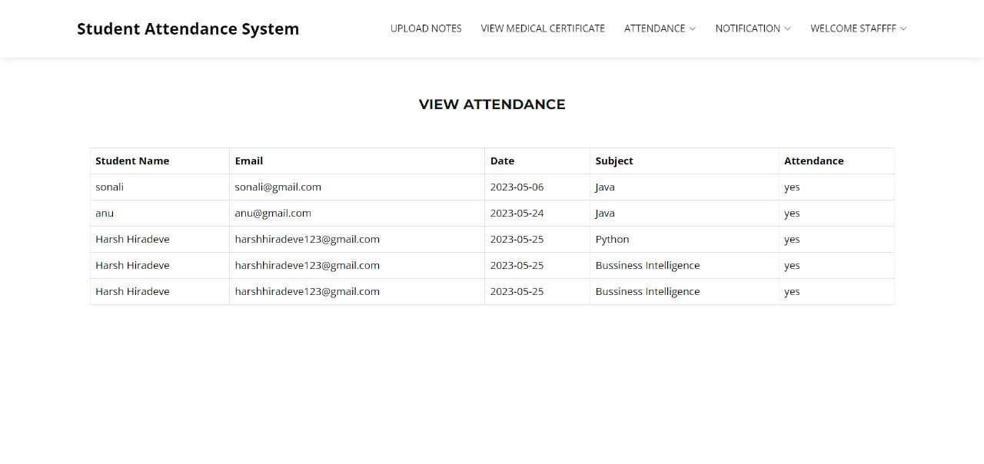

**Fig:-Staff login view Attendance**

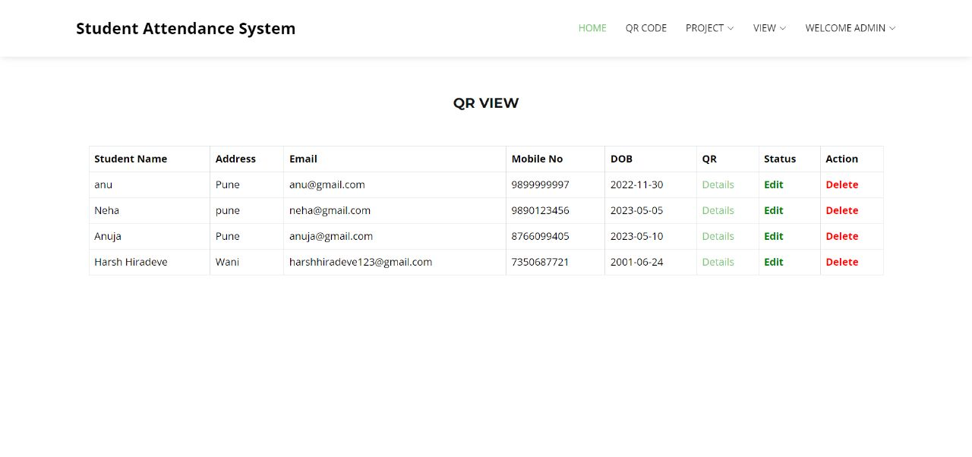

**Fig :-Admin login QR details**

**CONCLUSION**

Nowadays, being current with technology is essential, especially in the realm of education. The latest technologies are being used by educational institutions to improve the educational process. We believe that this system is basically essential for the University given the trend toward digitization. In this essay, we have discussed a potential system for recording student attendance that uses QR codes and internet-connected gadgets. This study demonstrates how the multifaceted and widely utilised QR code capability of smart devices may be used to efficiently record attendance in place of the previous, conventional approach of calling name lists in class.

**REFERENCES**

1.Muhammad Ayat Hidayat, HolongMarisiSimalango,”Students attendance system and Notification of college subject Schedule based on classroom using Ibeacon”, 2018 3rd International Conference on Information Technology, In- formation Systems and Electrical Engineering(ICITISEE), Yogyakarta, Indonesia, 978-1-5386-7082-8/18/.

2.Dr.Nkolika O. Nwazor, Mumuni M. Olusolape,”Cloud based Attendance Man- agementandInformation System”,(IJERT)ISSN: 2278-0181, Vol. 10 Issue 09, September-2021.

3.FawazAlassery, member IEEE,”A Smart Classroom of Wireless Sensor Net- works for Students Time Attendance System”,2019 IEEE Integrated STEM Education Conference (ISEC).

4.NandgopalDevnath,NitinPasi,”QR Code Based Smart Attendance System”, International Journal of Smart Business and TechnologyVol. 5, No. 1, (2017), pp.1-10.

5.VasutanTunbunheng,”Automatic Attendance Systemfor Late Student using Speech Recognitioncorresponding with Google Forms and Sheets”,2017 10th International Conference on Ubi-media Computing and Workshops (Ubi- Media).

6.Dongmei Feng, Peng Wang, Lei Zu, ”Design of Attendance Checking Manage-

ment System for College ClassroomStudents Based on Fingerprint Recognition”,978- 1-7281-5855-6/20/31.00c 2020 IEEE.

7.Jaehoon (Paul) Jeong¬, Minho Kim, Yeonghyeon Lee, and Patrick Lingga, ”IAAS: IoT-Based Automatic Attendance Systemwith Photo Face Recogni- tion in Smart Campus”,978-1-7281-6758-9/20/31.00 ©2020 IEEE.

8.Jack FebrianRusdi,Frans Richard Kodong,RichardusEkoIndrajit,Herry So- fyan,Abdurrohman,RobertMarco,”Student Attendance using Face Recog- nitionTechnology”,IEEE,2021.

9.Asri Nuhi,AgonMemeti,FlorindaImeri,BetimCico,”Smart Attendance Sys- tem using QR Code”,978-1-7281-6949-1/20/31.00 2020 IEEE.

10.Dr.S.Matilda, K.Shahin,” Student Attendance Monitoring System Using Im- age Processing”, international conference 2019,@IEEE.